Authors: Tony Cao, Julia Lee, Son Nguyen, Zirun Ye
Date: Oct 12, 2025
Course: CptS 415
Project Milestone 2 Report
1. Abstract:
The purpose of this report is to summarize the work completed for Milestone 2 of the project. Our team focused on preparing, transforming, and ingesting the dataset into a Neo4j database. The report presents the data preparation steps, schema design, data ingestion methodology, validation results, and performance metrics. The successful ingestion and querying of over 4.8 million papers demonstrate the system’s scalability and effectiveness for large graph datasets.
2. Problem Statement
The goal was to clean, transform, and ingest the dataset into an appropriate NoSQL database system chosen by the team, ensuring scalability and efficiency.
3. Dataset
In this milestone, the project utilized a reduced dataset with 8 keys per record from Kaggle: https://www.kaggle.com/datasets/devintheai/citation-networks (1.19 GB). This reduced dataset was selected to enhance efficiency during the initial stages of development. However, the final solution will be implemented using the original dataset introduced in Milestone 1, with modifications and reductions that suit our project objectives.
4. Data Preparation
We plan to transform the original JSON dataset into CSV format to improve visualization, reduce file size, and simplify ingestion into Neo4j. During data preparation, we performed several key steps, including reduction, cleansing, and transformation. The reduction phase involved filtering out irrelevant fields and incomplete records to minimize data size, while the cleansing process removed duplicates and invalid citation entries to ensure data consistency. The transformation phase converted the dataset from JSON to CSV format to meet Neo4j’s bulk import requirements.
To accomplish this, we implemented a parser that transformed raw JSON records into a flat CSV structure, extracting essential fields such as id, title, year, n_citation, doc_type, reference_count, references, and doi for each paper.
Pseudo-Code:
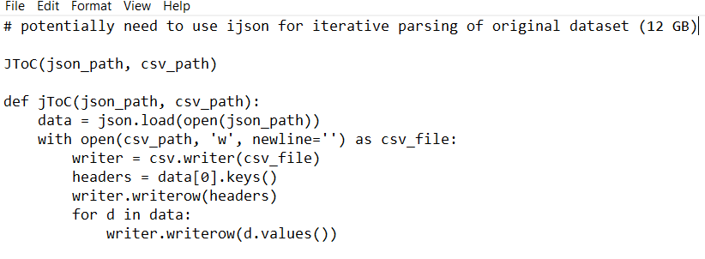
5. Database System
We have used Neo4j Community Edition. Neo4j is a graph-based NoSQL database, and hence it is the best fit for this dataset since it directly models citation relationships between papers as nodes and edges. This structure makes it possible to explore relationships and perform path queries effectively.
Cipher queries are easy to use to locate the most-cited papers, follow neighboring nodes or paths, and analyze subgraphs.
Scalability-wise, we used a special constraint on (:Paper {id}), indexed year and doi, and optimized memory and page cache settings. Under this setup, we ensured that Neo4j can support millions of nodes and edges. Neo4j also supports clustering or Fabric scaling when needed and is compatible with Hadoop/Spark, thus it can be easily utilized in future large-scale data analysis pipelines.
Non-Relational Schema:
Nodes (Paper) Label::Paper
Property | Description
id | Paper id (unique)
title | Paper title
year | Publication year
n_citation | Number of citations
doc_type | Type of document
Reference_count | Number of references
doi | DOI
Relationships (CITES):
The citation relationships are in the form (:Paper {id}) -[:CITES]-> (:Paper {id}), and this is a directed edge between one paper and another. We parsed the references column (semicolon-separated paper IDs) from the original data and created a CITES relationship from each paper to the papers it references.
Constraints and Indexes:
We also used a special constraint on (:Paper {id}) to prevent the duplication of paper nodes in the database, which also contributes to accelerating MERGE operations when data is being ingested. We also defined secondary indexes on (:Paper.year) and (:Paper.doi) because we expected that the two fields would be heavily utilized in our queries.
Why This Schema Fits Our Project:
Our dataset consists of such fields as id, title, year, n_citation, doc_type, reference_count, references, and doi. The basic question that we should ask is, who quotes whom? This is, in itself, relationship-related, as opposed to document properties. It is easy to express and run queries such as the most-cited papers (by examining in-degree), citation subgraphs of particular research areas or time periods, and path-based queries such as finding the shortest citation path between two papers by modeling citations as CITES edges in a graph structure. Such relationship-oriented queries would be far clumsier and slower in document-oriented or column-family databases, in which you would need to rebuild relationships through application logic. The Neo4j graph model allows us to operate directly on the citation network structure; hence, it was the correct selection for this project.
6. Data Ingestion and Query
We used Neo4j as our NoSQL database to store and query the academic paper citation network. The dataset, citation_network.csv, was approximately 1.19 GB in size and contained millions of paper–reference relationships. Although the milestone guidelines recommend using a reduced dataset between 10 MB and 500 MB, we successfully ingested the full dataset to evaluate the scalability of our implementation. The ingestion process was performed using a Python script (import_and_query_papers.py) that connects to Neo4j through the Bolt protocol. The script reads each row from the CSV file and uses Cypher queries to create (:Paper) nodes and [:CITES] relationships, effectively constructing a large citation graph. The ingestion process handled 4,894,402 paper records and completed in approximately 1 hour and 43 minutes (6,187 seconds), achieving an average processing speed of about 791 records per second. These results demonstrate that Neo4j is capable of efficiently handling large-scale data ingestion for graph-based datasets.
For the sake of experimentation, we also tried to use Cypher directly on Neo4j with the Load CSV clause on the data ingestion and query step, cutting down the time used to approximately 1 hour and 35 minutes. Following the same constraints, nodes, and relationships. This proved to be a little bit more efficient than using the Bolt protocol to connect Python to Neo4j. But this approach was also more complicated, requiring the user to know how to modify the memory heap to match the size of the database and better querying compared to using the Bolt protocol approach.
Validation:
After the ingestion was completed, we validated the dataset using several Cypher queries to confirm data correctness and completeness. The first query counted all papers in the database and returned 4,894,624 papers. The second query retrieved all papers with more than 100 citations, yielding 200 highly cited papers. The third query counted all citation relationships and returned 2,244,993 references. The outputs from these queries were saved as text and image files in the paper_query_output folder to provide verification evidence. Each validation query executed within 2–4 seconds, indicating that Neo4j efficiently indexed and queried the dataset despite its large size. The successful ingestion and validation of over 4.8 million paper nodes demonstrate the scalability and reliability of our data storage and processing approach.
7. Conclusion
In Milestone 2, the team prepared and transformed the data, designed a graph schema, ingested millions of records into Neo4j, and validated the database through efficient queries. The project demonstrates the scalability and suitability of Neo4j for large, relationship-driven datasets and provides a strong foundation for future milestones.
7. References
JSON to CSV conversion: https://www.reddit.com/r/DatabaseHelp/comments/1bqxfy7/convert_json_to_csv_or_xml/
json documentation: https://pypi.org/project/ijson/

